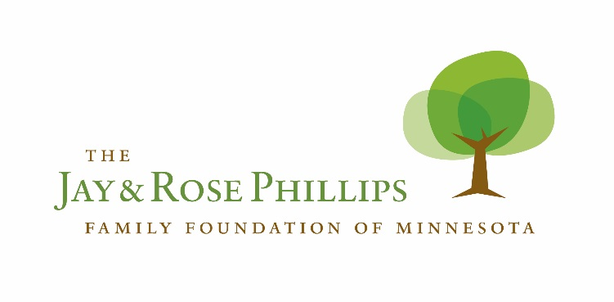

Call for Ideas and Proposals
Student Success and Creative Ownership in North Minneapolis
CORRECTIONS AND FREQUENTLY ASKED QUESTIONS

The Foundation released two Call for Ideas documents on August 29th, 2016. This document corrects several errors in those documents and addresses a number of questions that have subsequently been posed to staff.

We hope this is helpful to all prospective applicants. Please contact us to discuss your proposal ideas, or to clarify any questions about this opportunity.

If you have questions about Student Success, contact:
Joel Luedtke, Senior Program Officer
612-623-1651 / jluedtke@phillipsfamilymn.org

If you have questions about Creative Ownership, contact:
Elizabeth Coco “Coco”, VISTA Program Officer
612-623-1652
ecoco@phillipsfamilymn.org

If you have questions about the on-line submission process, contact:
Tracy Lamparty, Grants and Operations Manager
612-623-1656
tlamparty@phillipsfamilymn.org
CORRECTIONS
Call for Ideas- Student Success (Initial Publishing)- error has been corrected online as of 9/12/16
Page 4:
In the “How to Submit Your Concept” section, we incorrectly asked applicants to describe how their idea fits with the grantwriting area of “creative ownership”. This should have asked about fit with “Student Success”. Applicants to this funding area do not need to connect their work with the Foundation’s separate Creative Ownership strategy.

Info Session Presentation and PowerPoint:
In the first group information session conducted by the Foundation on Tuesday, September 13th, staff erroneously stated that the Foundation could not award funding to for-profit businesses or other non-charities. In fact, the Foundation can award funding to such organizations to enable them to pursue work of a charitable nature. The Foundation will work with businesses or non-charities to ensure that grant funds are properly managed and tracked.
**The Foundation is not able to award grants to individuals.

FREQUENTLY ASKED QUESTIONS
Can an organization submit separate proposals for both funding areas? Can organizations submit multiple proposals?
Yes to both questions. Applicants are welcome to submit ideas to both the Student Success and Creative Ownership review processes. Furthermore, organizations may submit multiple proposals to either or both of these opportunities. However, the Foundation would encourage prospective applicants to discuss their ideas with staff before submitting multiple applications in the same funding area. We would want to explore whether it instead might make sense to submit one larger proposals that covers several projects or ideas.

How much funding should applicants request?
There is no precise answer to this question. The Foundation plans to allocate up to $700,000 in grants this year across both funding areas. We hope to receive enough promising ideas to spread theses resources across a diverse range of efforts. We anticipate that most grants will be between $10,000 and $50,000. Applicants are certainly welcome to ask for more or less than this amount. Foundation staff, in coordination with our review committees, may seek to increase or decrease the amount requested during the proposal review process.

Will the Foundation work with applicants to adjust the scope of work or amount requested after proposals are submitted?
Yes. We anticipate that some proposals may need to be pared back or expanded during our review process. For this reason, applicants with multiple prospective projects may want to consider submitting one proposal that covers them all. We are willing to work from this “menu” to identify the project(s) with the most potential.

Are there any limitations or rules on how grant funds can be spent?
In general, no. Applicants should submit project budgets that accurately reflect their true financial needs to accomplish the proposed scope of work. The Foundation will not disallow administrative overhead costs, capital purchases, sub-granting, consulting costs, or any other reasonable expense. You know better than we do how much it costs to do your work.
However, the Foundation does have a few limitations on what it can fund:
- Foundation funds cannot be spent on direct lobbying activities. Talk to us if you have questions about whether your project might be considered lobbying.
- Businesses and other non-charities will be subject to additional financial management requirements to ensure that grant funds are properly spent on charitable activities.
- The Foundation cannot award funding to individuals. This also means that grant funds cannot be awarded to a fiscal agent or intermediary for the sole benefit of a predetermined individual.

Do grants have a 12-month term?
No. Grants can fund can be expended over a period of up to 12 months. If your project only requires 6 months to complete, the Foundation will be happy to discuss your progress and consider additional funding at that point.

Will the Foundation consider schools outside of North Minneapolis in the Student Success category?
Yes, IF you can show that a large number of North Minneapolis students attend this school. Please provide specific enrollment data.

Can a business apply for a grant?
Yes, but funds can only be awarded to support specific charitable activities of a business. If grant funds are awarded to a business or other non-charity, the Foundation will work closely with that organization to ensure that all IRS oversight rules are diligently followed.

Will the Foundation fund capital requests?
With only $700,000 available to support both Student Success and Creative Ownership ideas, this is not an ideal opportunity to request major capital support. Furthermore, the 12-month maximum timeframe for this process is probably not compatible with efforts to raise substantial capital for construction costs or endowments. However, if your capital need is modest and can be realized quickly, feel free to apply.
Any applicants seeking funding for capital needs are encourage to talk to staff prior to submission.

Will the $700,000 be split evenly between Student Success and Creative Ownership?
Not necessarily. Funds will be awarded to the strongest applications. Both funding areas will receive significant support, but this may not mean exactly $350,000 for each category.

