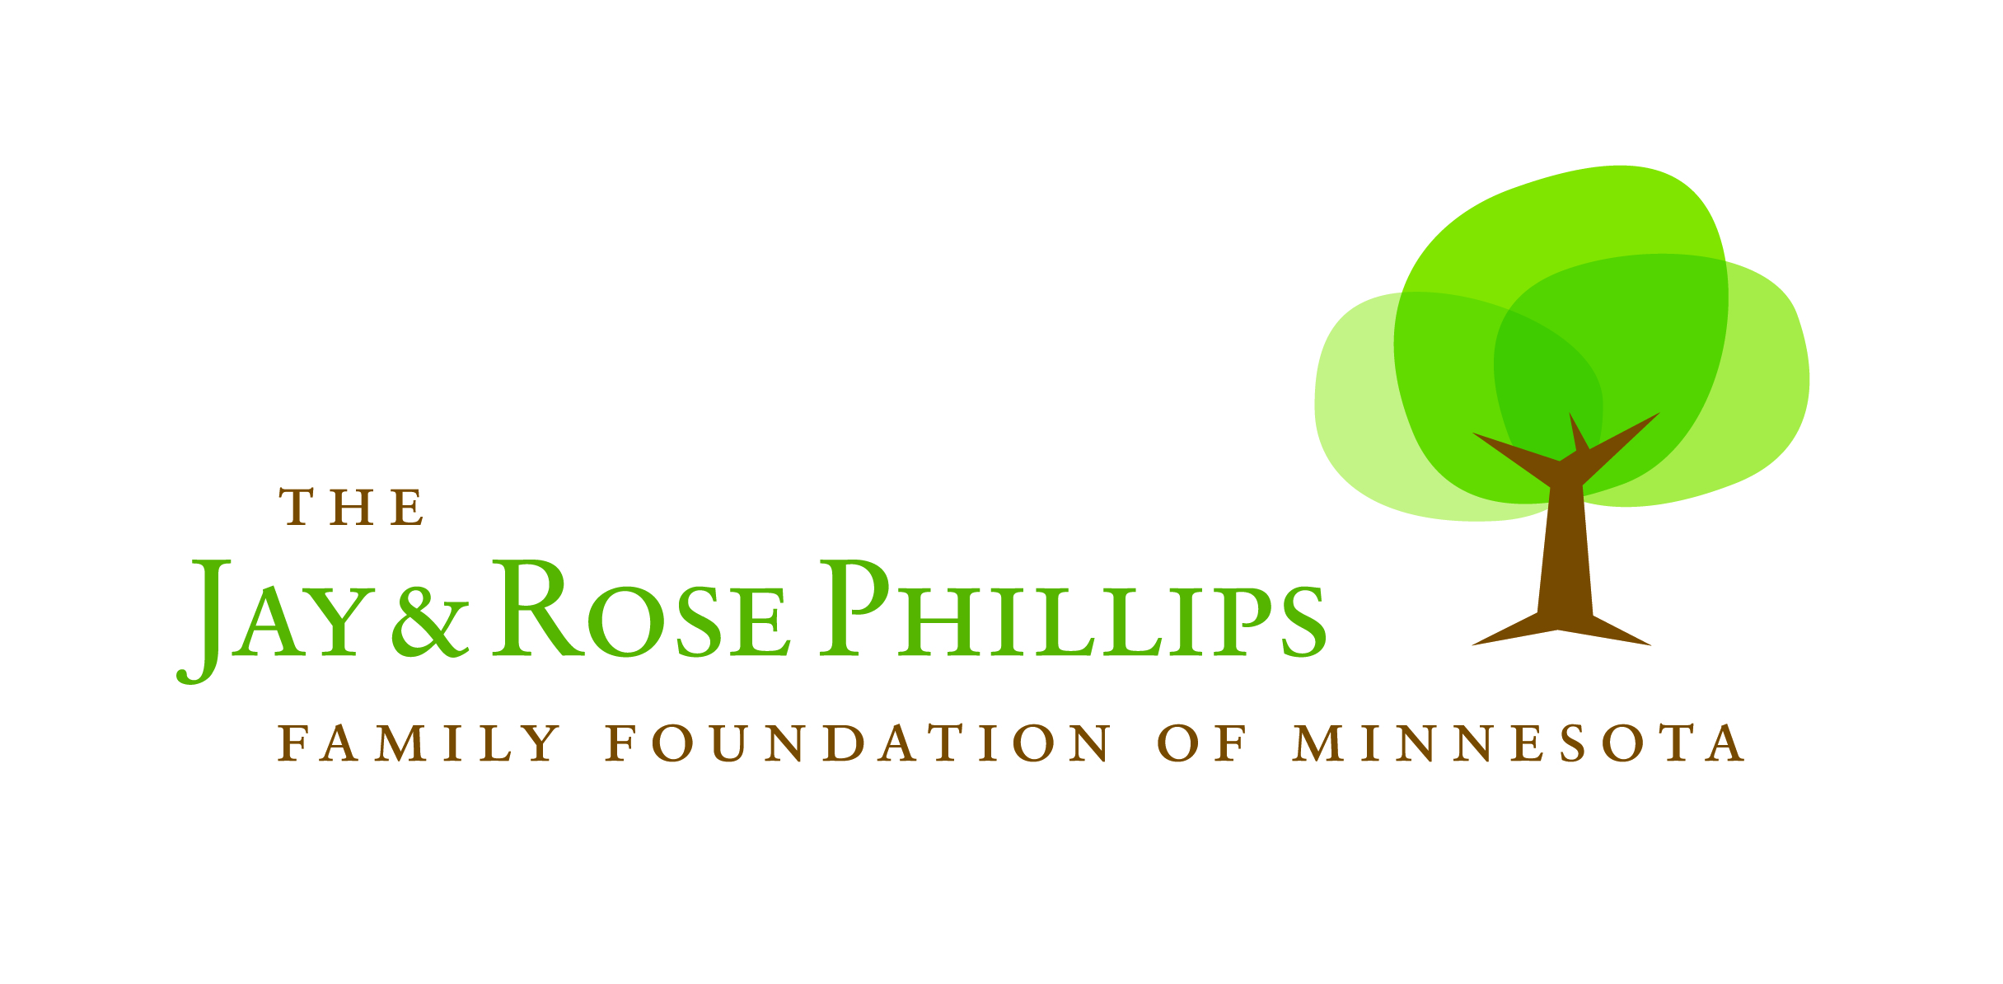
Conference Room Request Form

Please fill out the following information and return the form to the Foundation’s Grants and Operations Manager, Tracy Lamparty. You may call or email with questions at 612-623-1656 or tlamparty@phillipsfamilymn.org. She will respond to your request within 24 hours.

Organization Name:

Purpose of the Meeting:

Date you would like to use the conference room:

Set-up Time:

Meeting Time (beginning and ending):

Number of attendees:

Will you be using the projection system?

If so, do you need access to a laptop or will you bring one with you?

Will you be bringing in food/beverages?

Would you like coffee and/or water provided? If so, how much?

Will you be using the Foundation’s dishes?

Main Contact (Name and contact information):

Backup Contact (Name and contact information):

Onsite Contact Name (contact information if different from above):

Please make sure to read through the conference room guidelines before confirming your request. They can be found on the website or contact Tracy Lamparty to email a copy of them to you.

